

**DATA VISUALIZATION AND KNOWLEDGE MAPPING**  
  
-------------------------------------  
([**MIS376)**](https://aybuzem.aybu.edu.tr/course/view.php?id=26699)  **PROJECT**-------------------------------------

[**H.**](https://aybu.edu.tr/dfindik/custom_page-293-iletisim.html) **Kemal İLTER**

----------------------------------------

**Prepared by;**

**Ayberk ÜNVEREN / 17030411044**

**Abstract:**  
 In this project, I will examine the effects of coronavirus on society in Turkey. For more details in this review, I found companies with closings and unemployment rates in some countries. The Union of Chambers and Commodity Exchanges of Turkey shows the number of closed and opened companies on a monthly basis. In more detail, the numerical data was disclosed by company type. From this data, I only extracted the number of companies that were closed and opened in total monthly. So I got the datasets.

In order to conduct detailed research, instead of addressing all of Turkey's social problems, I examined their economic effects. In this review process, I wanted to stay true to the complementarity and integrity of the state. I have come across many politicians, economists, newspapers and researchers who criticize the economic power of the state. This can be one of the negative effects of the process. I had difficulty in collecting data due to the multiplicity of opposing views. My first aim was to be objective and at the same time preserve the sanctity of the state. That's why I considered opposing views. In line with the information I obtained, I decided to obtain my data from the Union of Chambers and Commodity Exchanges of Turkey. Because I could not find the datas which I need to use in my project in Statistical Institution's website. Their datas are not up-to-date and it was a problem for me. There are lots of datas, news and speechs about this subject but I should had to used reliable datas. I used the World Economic Database, which I believe is reliable, opened by the International Monetary Fund to access unemployment data around the world.

In the last stage I had to visualized the datas which I found and I chose the Visme tool to visualize my data based on this information. Because I found the most suitable templates for the tables I created for project. Also this tool made my job easier because it is a tool which is free and easy to use.

**Senario:**   
  
 Before I present to you the scenario that inspired me to clarify my research in this project, I would like to share with you a part of the article published in January 2020 that examines the effects of the pandemic. The data in the excerpt you see helped me gain some insight into the very serious effects of the economy on the world during the pandemic.

*“The COVID-19 pandemic has had far-reaching consequences beyond the spread of the disease and efforts to quarantine. As the SARS-CoV-2 virus spread around the world, concerns shifted from supply-side manufacturing issues to declining jobs in the service sector.*

*The pandemic caused the largest global recession in history, with more than a third of the world's population in quarantine at the time. There have been examples of price gouging. There are widespread reports of drug shortages, with panic buying and consequent shortages of food and other staples in many areas. Senior officials at the United Nations estimated in April 2020 that a total of 265 million people could starve to death by the end of 2020. The technology sector, in particular, warns about delays in electronic goods shipments. As of February 28, 2020, stock markets around the world saw their biggest weekly drop since the 2008 financial crisis. Global stock markets crashed in March 2020, with the world's major indices dropping a few percent. As the pandemic spreads, global conferences and events in the fields of technology, fashion and sports are being canceled or postponed, but the monetary impact on the travel and trade industry is yet to be estimated, billions and likely to increase.”*

After these serious results we have seen, I would like to tell you what I will do in my own work. In my work, I will try to explain by giving an example from a relative of mine. I will talk about how small business owners are affected by the economic situation during the pandemic process, what kind of support the government provides to these businesses, and what kind of consequences business owners have to deal with.

I would like to present you the story of my friend who opened a small cafe before the pandemic process. There is a business opened at the beginning of 2019. This company was in the heart of the city, in a busy place and was really attracting a lot of attention. The owner was making a profit and keeping his employees happy. With the start of the pandemic process, the business owner had to allocate his profit income to rent and employees' salaries. But this process did not last long. Along with the curfews in the pandemic, it was decided to close cafes and restaurants. Despite this, rents were being paid and staff still seemed to be working. Due to the prolongation of this process, the owner of the business was helpless about rent and salary payments. The only solution was to shut down the business. With the closure of this business, the dreams of the business owner were shattered. Many workers were unemployed. There are also psychological and social effects in the background of this process. In line with this story, I decided to examine the effects of coronavirus on society in Turkey.

**Introduction:**   
  
 The Corona virus, which emerged in China towards the end of 2019, quickly spread all over the world. While the pandemic process is still continuing, almost all countries of the world were affected by this virus until the first half of 2020. People began to be affected psychologically.

At first, no one knew how the process would work. Countries began to take measures. Corona virus, which first came to Turkey on March 10, 2019, caused serious damage to certain sectors in the country. These; health, economy, employment, tourism, etc. However, on the basis of all of them, the damage caused by the economy to both the world and our country has actually been the main reason for the interruption of other sectors. For example, the economic crisis has caused many companies to lay off their employees, take unpaid leave or make various cuts. These cuts started with the measures taken to reduce the Corona virus. Some countries have taken measures economically.

In this process, people were able to clearly see the difference between 'developed countries' and 'developing countries'. Because the economy of some countries was not enough to protect the welfare level of the people from the pandemic process. These issues have become more apparent as the pandemic progresses.

The biggest repercussions of the economic problems were felt by smaller investors trying to run their own business. Among them: cafe, restaurant, pub, game room owners can be counted. The main reason smaller businesses of the type I'm talking about are so affected is because the customer must be physically present and the expenses must be direct. However, the fact that such places had to be closed in line with the measures taken during the pandemic process affected them much more negatively in terms of business. Many tradesmen had to close their businesses.

According to research, the number of people affected by the economy is increasing. At this point, the point I would like to draw attention to was the companies that closed due to the coronavirus. These companies can be divided into individuals proprietorship and companies. For a more comprehensive study, I looked at the data for both 2020 and 2021. According to the data announced by the Union of Chambers and Commodity Exchanges of Turkey, I have reached the number of companies opened and closed.

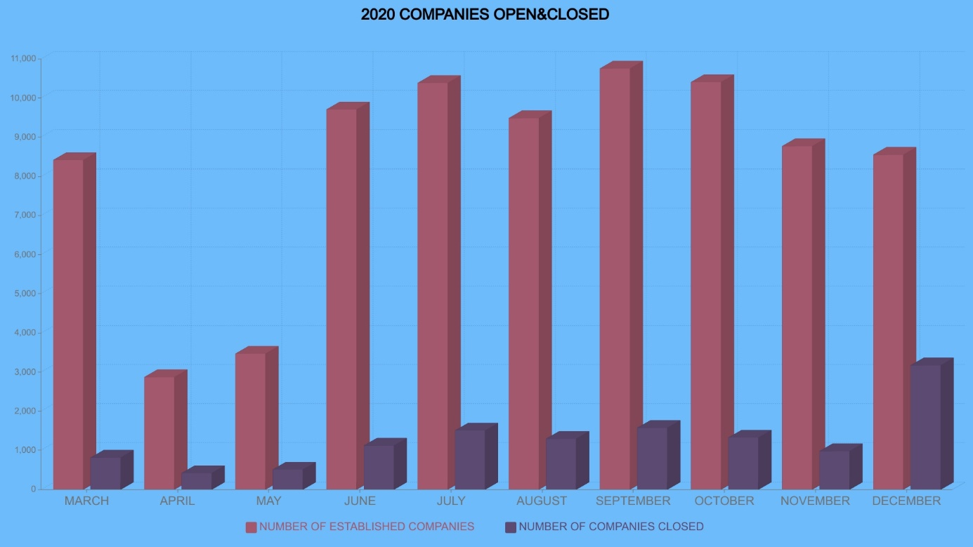

**The pandemic process became more effective towards the end of 2020 in Turkey. We can see this in the chart above. Towards the end of 2020, the number of companies closing gradually increased.**

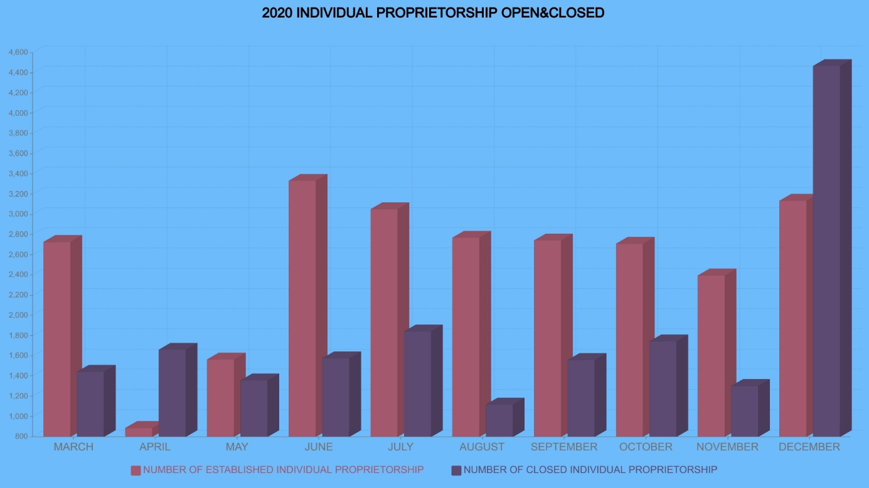

**In addition, when we examine individual proprietorship, we encounter the same situation.**

Towards the end of the year, we see an increase in the number of companies closing. Additionally, we are seeing a significant increase in the number of individual proprietorship closing in December 2020.

The operation of the process in Turkey was different from other countries. As we can see from the data, you have revived the economy a little more thanks to the loosened measures during the pandemic process at some time intervals. But soon after, due to the increasing number of cases, the measures were tightened again. Parallel to this, the economy started to deteriorate again. In other words, we can clearly see the increase in the number of trapped companies.

In Turkey, individual aid and aid to companies and tradesmen were not enough. When the determined economic plans were examined, many steps were taken to strengthen the economy. But its effects were not visible to the public. Purchasing power began to decrease gradually. To explain this concretely, let's look at the number of companies closing in 2021.

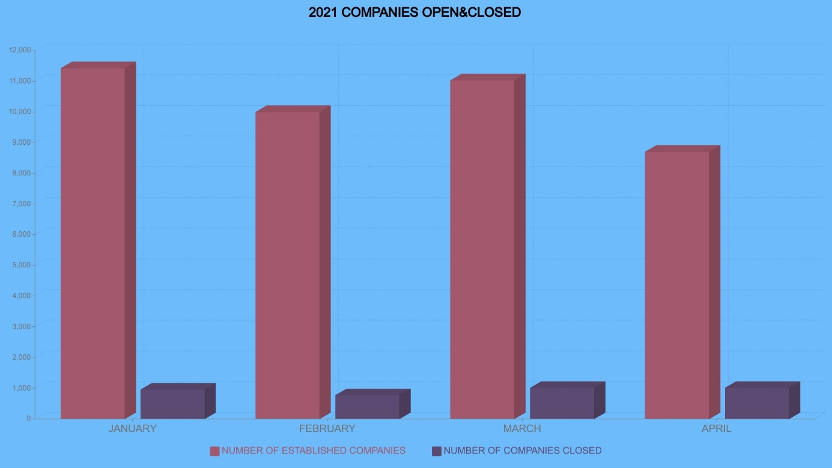  
 **There is a steady increase in the number of companies closing down. We cannot say that it has increased too much or decreased too much. Because at the beginning of 2021, the economic effects of the pandemic had increased. People were bored with the pandemic process. And psychologically, it was not possible to stick to the rules during the pandemic process. Despite the prohibitions, there were small tradesmen, individual property owners, who tried to open their businesses. Now, let's look at data from individual proprietorship in 2021.**

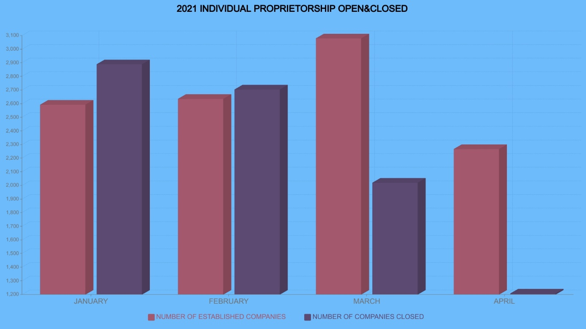

**At this point, we see a radical decline. There is a significant decrease in the number of individual properties closing in April 2021. Because the economy in Turkey was getting worse, the movements to strengthen the economy had accelerated in April 2021. This fix is ​​still in progress.**

As a result of my research, I saw that Turkey is not the only country that is economically affected by the pandemic process. In other words, almost every country has been affected by a certain amount of pandemic. As a result of foreign and domestic trade, it caused serious damage to the economy of this country. The most accurate way to do an economic study around the world was to look at unemployment rates. I reached these rates with the help of the data announced by the International Monetary Fund. I studied unemployment rates in 2019, 2020 and 2021. Here are some changes. For example, when we focus on Turkey, while there was an increase in the unemployment rate in 2020, this rate decreased in 2021.

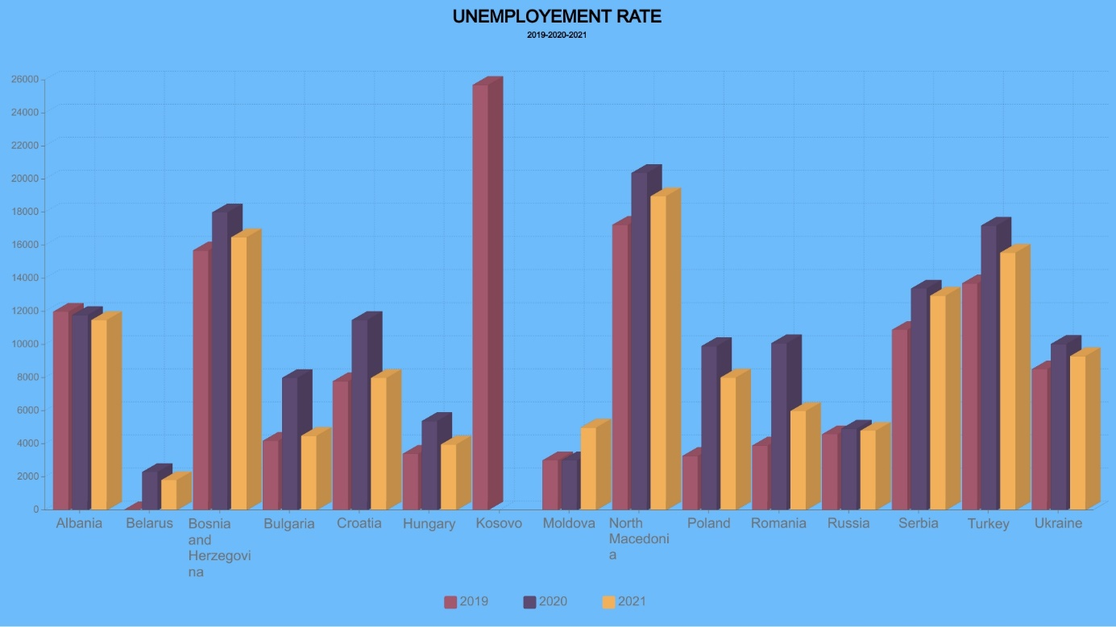

**When we examine this graph in general, we can see the effects of the pandemic process with the increase in the unemployment rate in the countries.**

**References:**

* The Effects of the Pandemic on the Turkish Economy and the Measures Taken by the Central Bank of Turkey to Ensure Financial Stability (Havva ARABACI [1] , Duygu YÜCEL [2]) (<https://dergipark.org.tr/en/download/article-file/1115243>)
* Effects of the Covid-19 Pandemic Process on Employment in Turkey and Measures to be Taken by the Public (Guldenur ÇETİN [1] , Yusuf BALCI [2]) (<https://dergipark.org.tr/en/download/article-file/1165930>)
* Covid-19 Pandemic: Its Effects on the Workforce and Employment Measures (Elif KARA [1]) ( <https://dergipark.org.tr/en/download/article-file/128141> )
* Macroeconomic Analysis of the Effects of the Covid-19 Pandemic on the Turkish Economy (Muhittin ADIGÜZEL [1]) ( <https://dergipark.org.tr/en/download/article-file/1166150> )
* Effects Of Covid-19 On Business And Research (Naveen Donthu, Anders Gustafsson) ( <https://www.ncbi.nlm.nih.gov/pmc/articles/PMC7280091/> )
* Psychological & Social Effects Of Pandemic Covid-19 On Education System, Business Growth, Economic Crisis & Health Issues Globally (Sakshi Srivastava, Dr. Nidhi Agarwal)

(<https://www.globusjournal.com/wp-content/uploads/2020/09/GMIT-JJ20-Sakshi-Srivastava.pdf>)